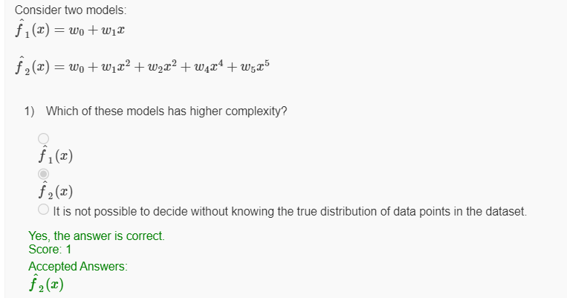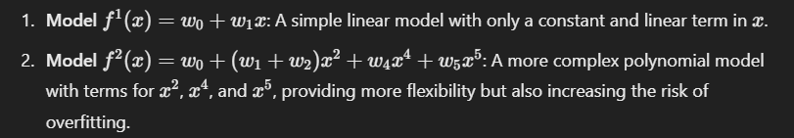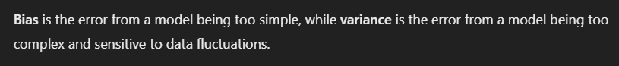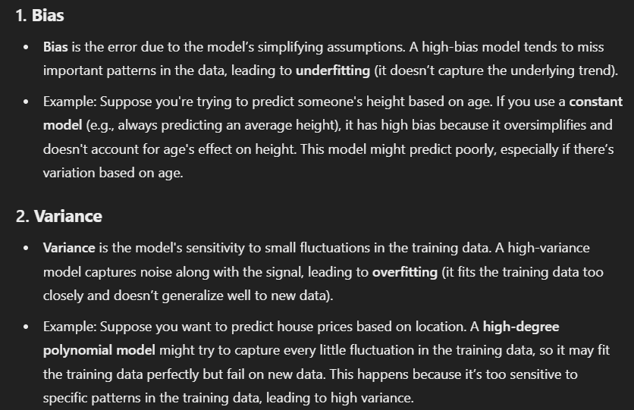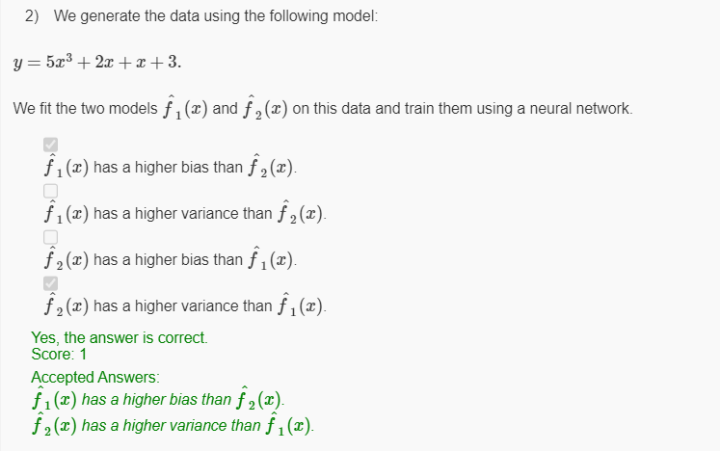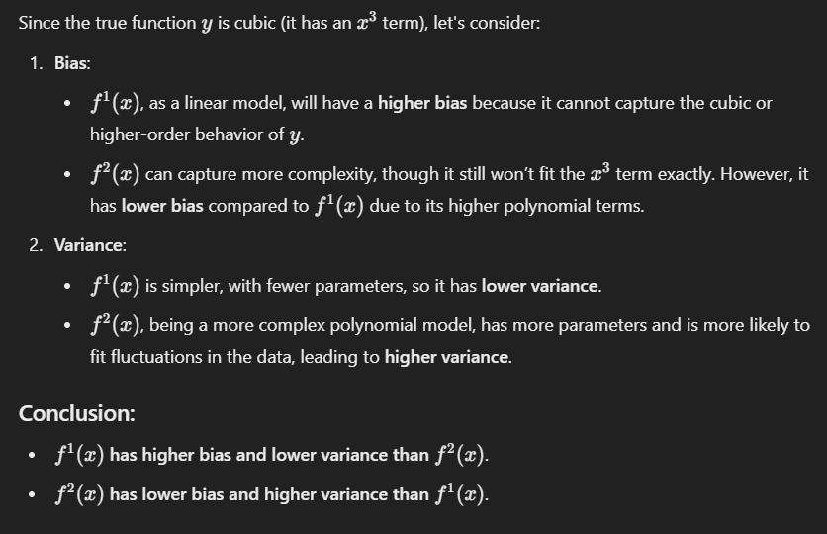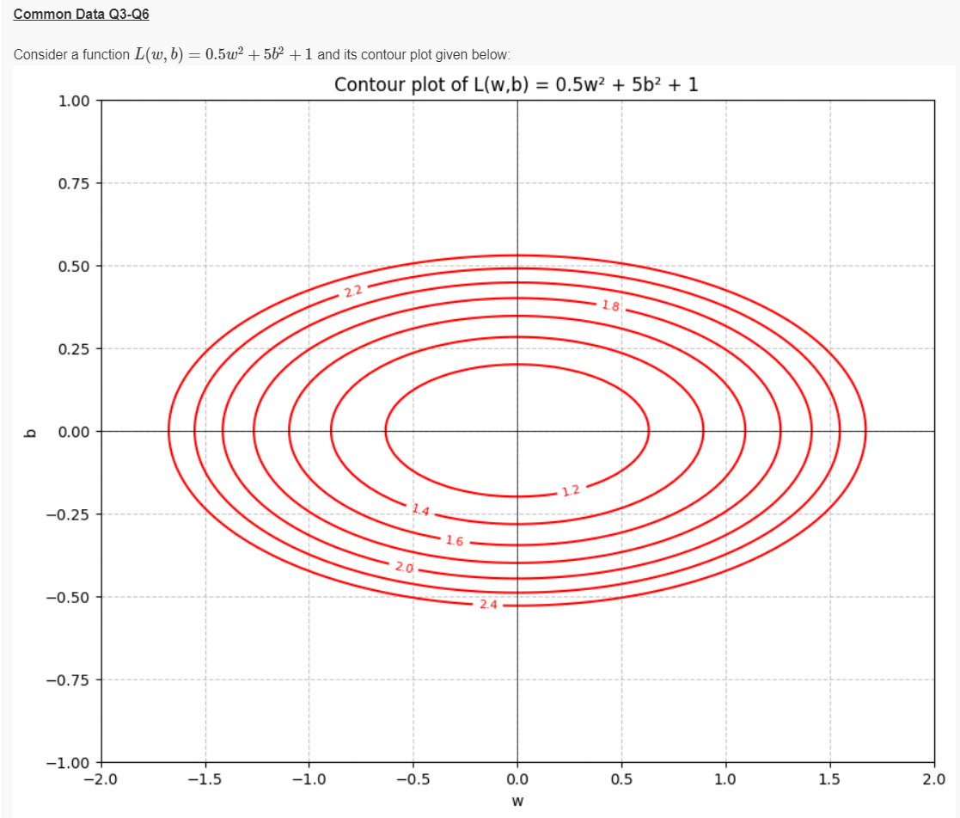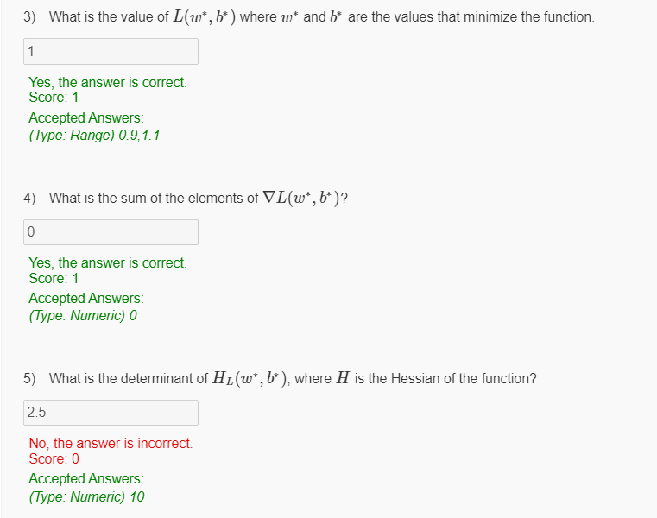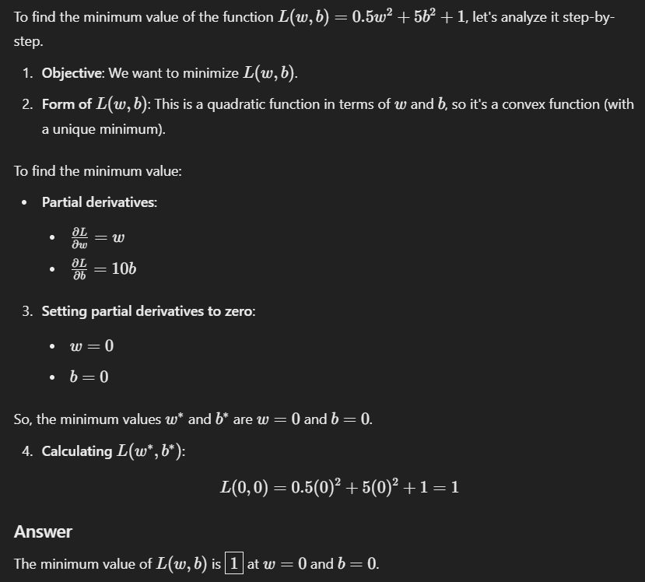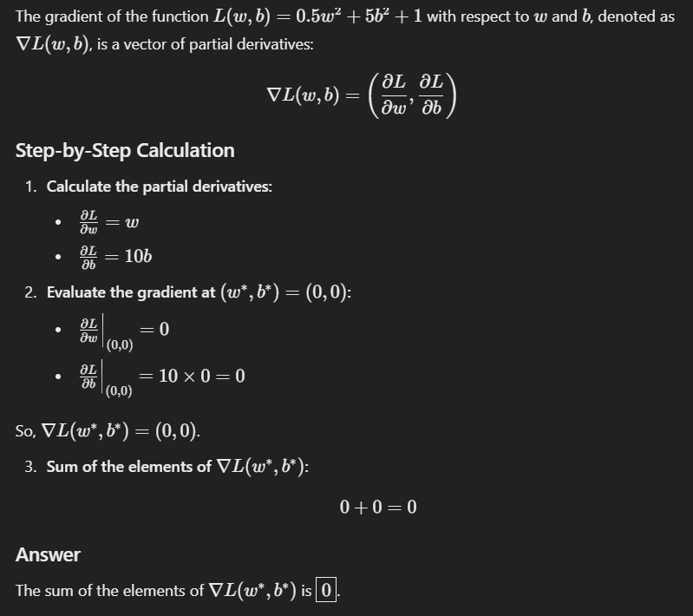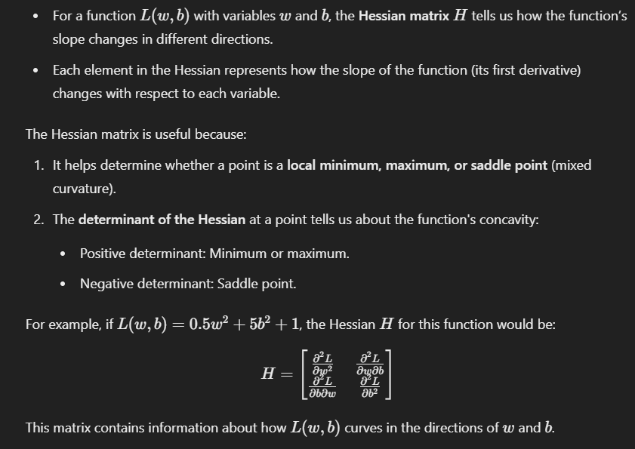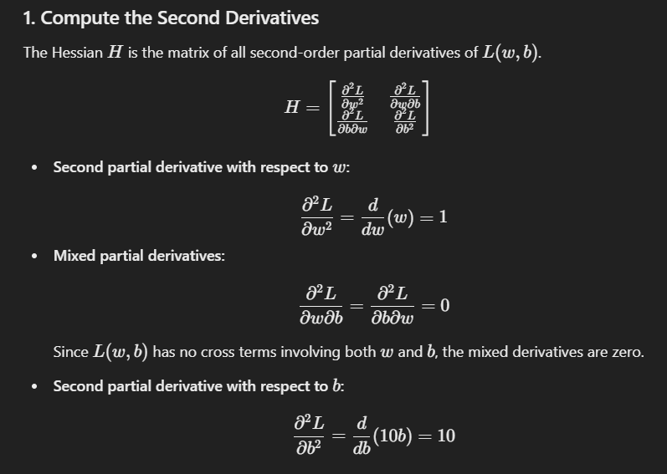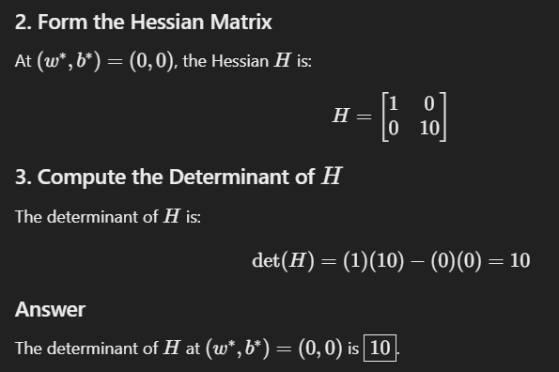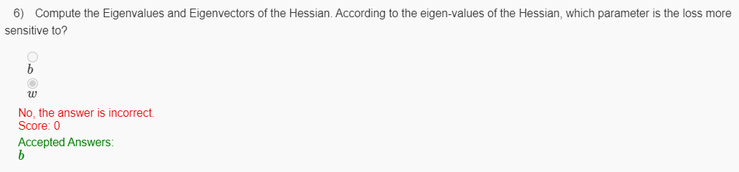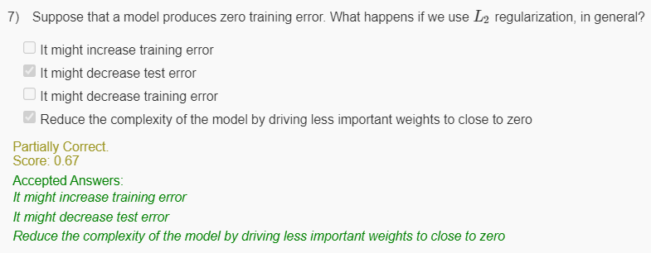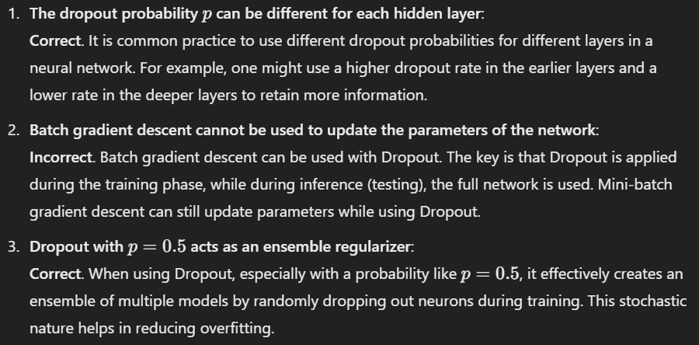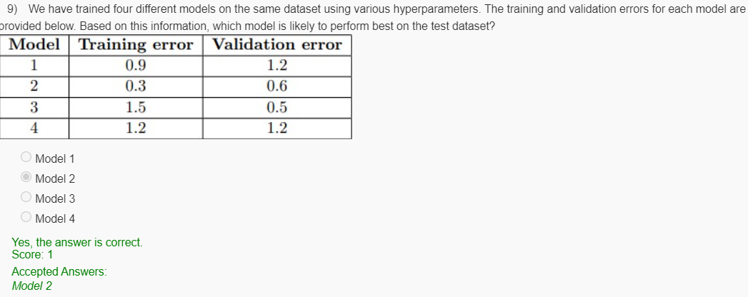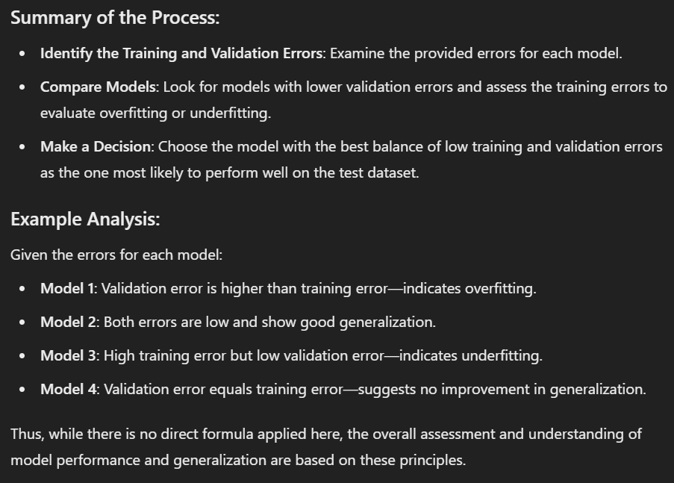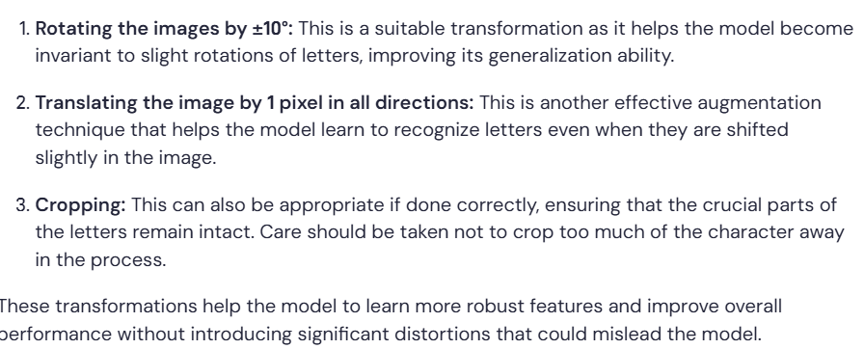

Which of the following statements is true about the bias-variance tradeoff in deep learning?

**Options:**

1. Increasing the learning rate reduces bias
2. Increasing the learning rate reduces variance
3. Decreasing the learning rate reduces bias
4. None of These

**Answer:**

* **None of These.**

**Explanation:**

1. **Increasing the learning rate reduces bias:** While a higher learning rate can make the training process faster, it does not inherently reduce bias. Bias is related to the model's ability to capture the underlying patterns in the data; a model can still be biased regardless of the learning rate.
2. **Increasing the learning rate reduces variance:** Increasing the learning rate can lead to overshooting during training, potentially resulting in a higher variance rather than a reduction in it. A high learning rate can cause a model to be less consistent across different training runs and more prone to fluctuations in the learned patterns.
3. **Decreasing the learning rate reduces bias:** A lower learning rate might allow a model to train more thoroughly and potentially learn more complex patterns. However, decreasing the learning rate itself does not directly reduce bias; it may help improve model training but does not guarantee a decrease in bias.

In summary, none of the provided options correctly capture the relationship between learning rate adjustments and the bias-variance tradeoff in deep learning. Thus, the correct answer is **None of These.**

Which of the following statements is true about the bias-variance tradeoff in deep learning?

**Options:**

1. Increasing the size of the training dataset reduces bias
2. Increasing the size of the training dataset reduces variance
3. Decreasing the size of the training dataset reduces bias
4. Decreasing the size of the training dataset reduces variance

**Answer:**

* **Increasing the size of the training dataset reduces variance.**

**Explanation:**

1. **Increasing the size of the training dataset reduces bias:** While a larger dataset can help in better estimating the underlying true function, it does not guarantee a reduction in bias by itself. Bias is primarily influenced by model complexity and assumptions, not just the size of the dataset.
2. **Increasing the size of the training dataset reduces variance:** This statement is true. By providing more data, the model can learn more generalized features and reduce its sensitivity to noise present in the training dataset, which helps to lower variance. A larger dataset helps to average out individual anomalies or fluctuations.
3. **Decreasing the size of the training dataset reduces bias:** This statement is false. Reducing the training dataset size generally increases bias because the model may not be able to capture the underlying patterns accurately due to insufficient data.
4. **Decreasing the size of the training dataset reduces variance:** This statement is also false. Decreasing the dataset size can lead to higher variability in model predictions, as the model might become overfitted to the smaller set of examples, capturing noise instead of the true underlying distribution.

In summary, the most accurate statement regarding the bias-variance tradeoff is that increasing the size of the training dataset reduces variance, which improves the overall generalization of the model. Thus, the correct answer is **Increasing the size of the training dataset reduces variance.**

**Question:**

What is the effect of high bias on a model's performance?

**Options:**

1. The model will overfit the training data.
2. The model will underfit the training data.
3. The model will be unable to learn anything from the training data.
4. The model's performance will be unaffected by bias.

**Answer:**

* **The model will underfit the training data.**

**Explanation:**

High bias occurs when a model is too simplistic to capture the underlying patterns of the data, leading to oversimplification. This causes the model to perform poorly on both the training set and the test set, resulting in underfitting. It fails to learn from the training data adequately and cannot generalize well to new instances, leading to high errors in both cases. Therefore, high bias primarily leads to underfitting.

**Second Question:**

**Question:**

What is the usual relationship between train error and test error?

**Options:**

1. Train error is usually higher than test error
2. Train error is usually lower than test error
3. Train error and test error are usually the same
4. Train error and test error are unrelated

**Answer:**

* **Train error is usually lower than test error.**

**Explanation:**

In machine learning, the training error represents how well the model performs on the training dataset, while the test error indicates how well the model generalizes to unseen data. Typically, the training error is lower than the test error because the model is optimized to perform well on the data it was trained on, potentially capturing noise and specifics of that dataset. Consequently, when evaluated on a separate test set, the model often shows a higher error rate due to its inability to generalize effectively outside the training data. This observation highlights the common issue of overfitting

**Question:**

What is overfitting in deep learning?

**Options:**

1. When the model performs well on the training data but poorly on new, unseen data
2. When the model performs poorly on the training data and on new, unseen data
3. When the model has a high test error and a low train error
4. When the model has a low test error and a high train error

**Answer:**

* **When the model performs well on the training data but poorly on new, unseen data.**

**Explanation:**

Overfitting occurs when a model learns the training data too well, capturing noise and details that do not generalize to unseen data. As a result, while it may have a very low training error, its ability to predict accurately on new data is compromised, resulting in high test error. This is a key characteristic of overfitting.

**Second Question:**

**Question:**

How can overfitting be prevented in deep learning?

**Options:**

1. By increasing the complexity of the model
2. By decreasing the size of the training data
3. By adding more layers to the model
4. By using regularization techniques such as dropout

**Answer:**

* **By using regularization techniques such as dropout.**

**Explanation:**

Regularization techniques, such as dropout, L1 regularization, and L2 regularization, help to penalize complexity in models, encouraging them to generalize better to unseen data rather than merely memorizing the training data. Dropout, in particular, randomly sets a portion of the neurons to zero during training, which helps in reducing reliance on any single path within the network and thus combats overfitting. Increasing model complexity or adding more layers typically exacerbates overfitting.

**Third Question:**

**Question:**

Which of the following statements is true about L2 regularization?

**Options:**

1. It adds a penalty term to the loss function that is proportional to the absolute value of the weights.
2. It adds a penalty term to the loss function that is proportional to the square of the weights.
3. It gives us sparse solutions for w.
4. It is equivalent to adding Gaussian noise to the weights.

**Answer:**

* **It adds a penalty term to the loss function that is proportional to the square of the weights.**

**Explanation:**

L2 regularization (also known as weight decay) incorporates a penalty term to the loss function that is proportional to the square of the weights (∥w∥2∥*w*∥2). This effectively discourages large weights, promoting smaller weight values across the model's parameters. It does not inherently produce sparse solutions; that property is more associated with L1 regularization. Hence, the correct statement is that L2 regularization adds a penalty that is proportional to the square of the weights.